Lab 11: Data Structures and Algorithms Topic: Heaps

# Objective

* Working with Heaps and Heap Sort

# Task 1

Write the functions to insert values in:

* min heap
* max heap

# Task 2

Write the functions to delete a value from:

* min heap
* max heap

# Task 3

Using functions made in Tasks 1 and 2, write the functions for heap sort for sorting values in:

* Ascending order using min heaps
* Descending order using max heaps

# Task 4

Given a binary tree we need to check it has max-heap property or not. Binary trees need to fulfill following two conditions for being a max-heap:

1. It should be a complete tree (i.e. all levels except last should be full).
2. Every node’s value should be greater than or equal to its child node (considering max-heap).

For example, the following tree is a max-heap:

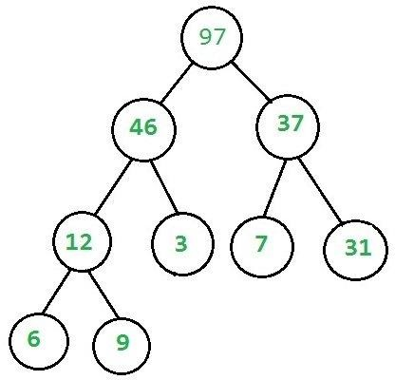

The following tree does not fulfill max-heap properties:

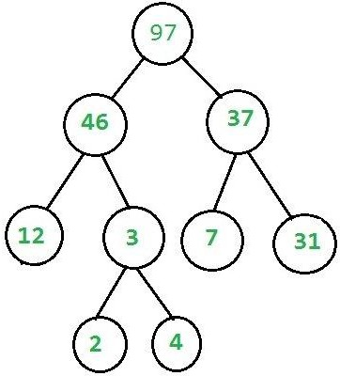

Your task is to make a generic code to check whether a given tree is a max-heap or not?